Constructing Regular Heptagon

Definition
# Source: AI Source: Provided by: [Data Path: Persons Table -> ID Column: 1, Name_En Column: Motasem Essam] -> From: [ChatGPT] on [7/25/2026]
Constructing a Regular Heptagon is the geometric construction of a seven-sided polygon in which all seven sides are equal and all seven interior angles are equal, using geometric construction methods.
For a regular heptagon $ABCDEFG$:
$$\boxed{AB=BC=CD=DE=EF=FG=GA}$$
and:
$$\boxed{∠A=∠B=∠C=∠D=∠E=∠F=∠G}$$
Each interior angle is:
$$\boxed{\frac{{900}^{∘}}{7}≈{128.571}^{∘}}$$
Each central angle is:
$$\boxed{\frac{{360}^{∘}}{7}≈{51.429}^{∘}}$$
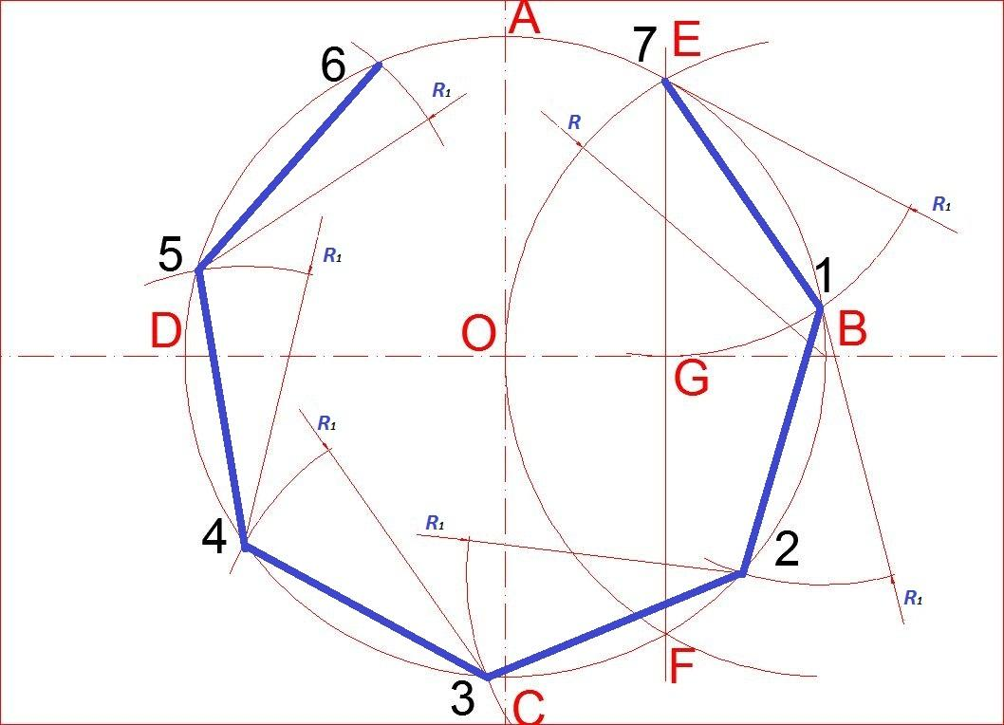
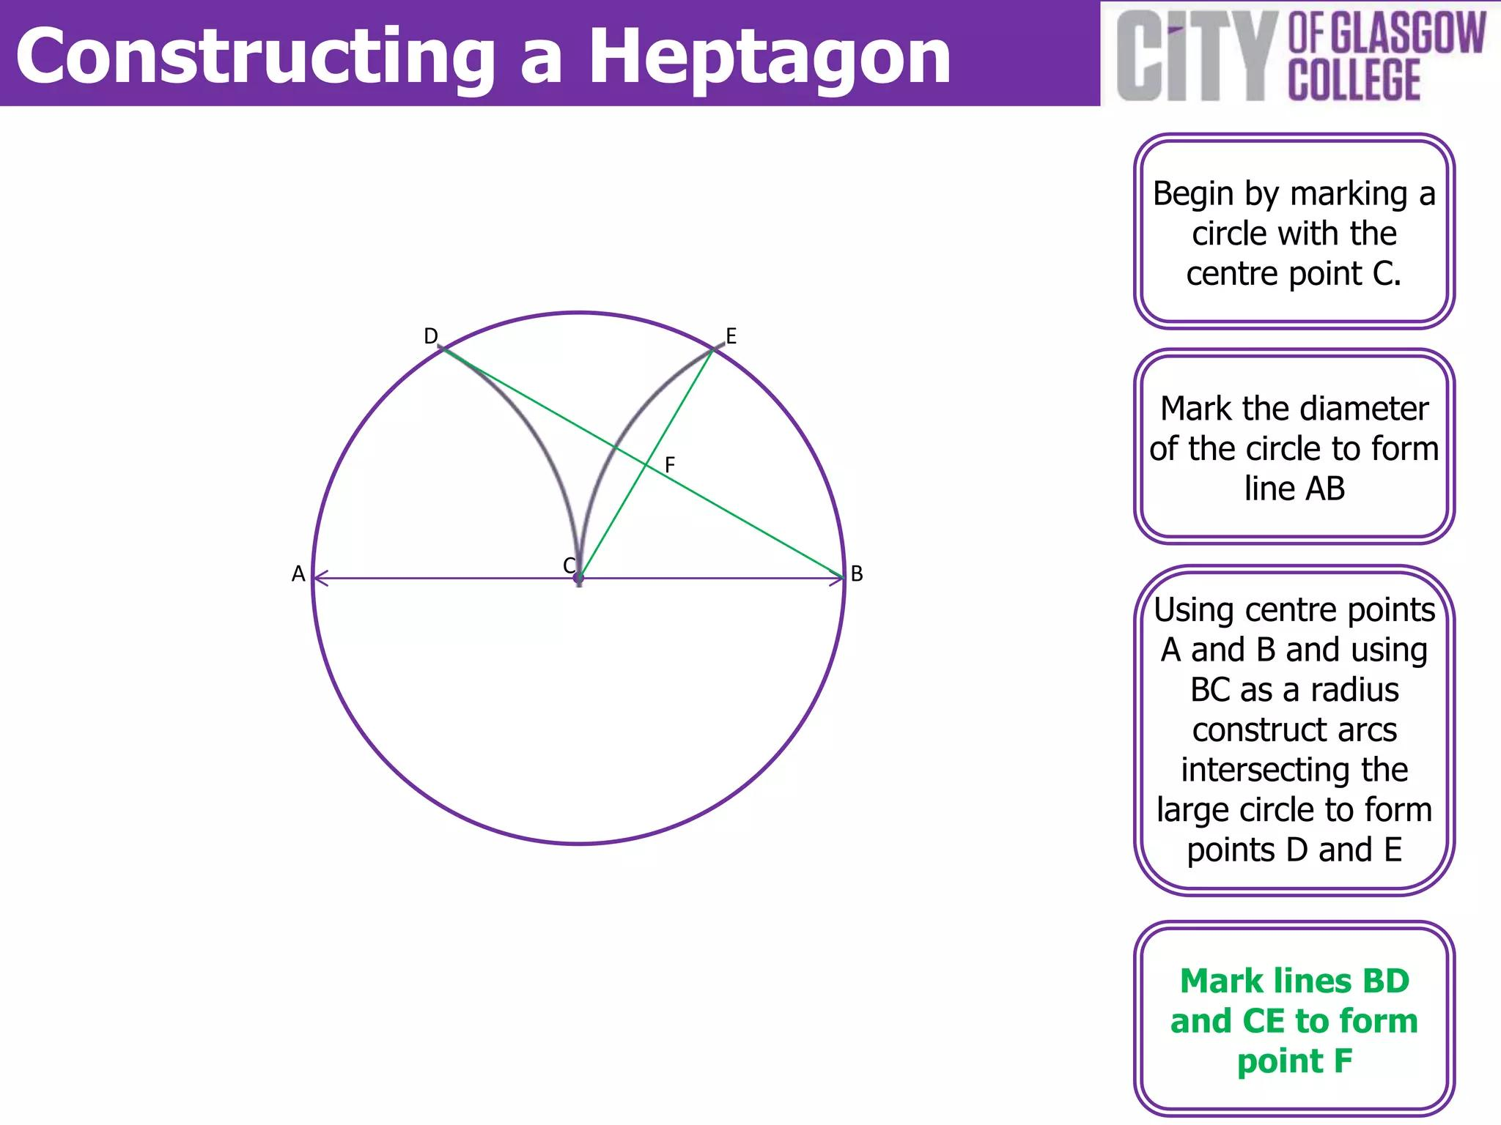
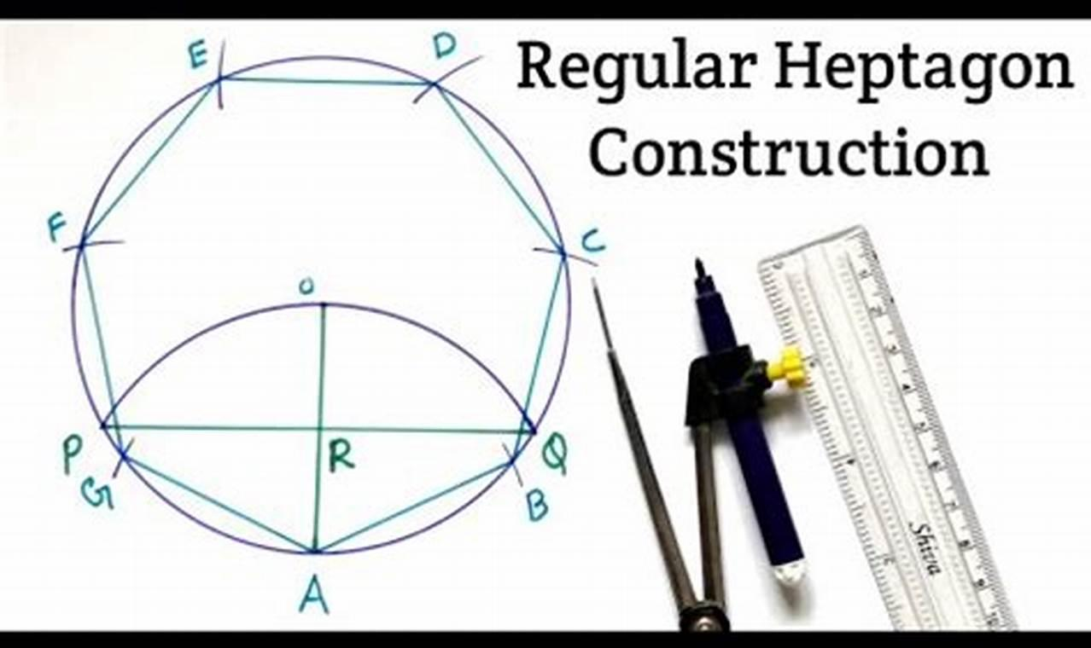
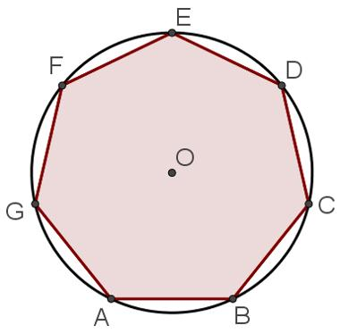

Fundamental Concept
# Source: AI Source: Provided by: [Data Path: Persons Table -> ID Column: 1, Name_En Column: Motasem Essam] -> From: [ChatGPT] on [7/25/2026]
A regular heptagon is a regular polygon with:
$$n=7$$
The sum of its interior angles is:
$$\left(7-2\right){180}^{∘}={900}^{∘}$$
Therefore, each interior angle is:
$$\boxed{\frac{{900}^{∘}}{7}≈{128.571}^{∘}}$$
The central angle between consecutive vertices is:
$$\boxed{\frac{{360}^{∘}}{7}≈{51.429}^{∘}}$$
Unlike the regular triangle, square, pentagon, and hexagon, a regular heptagon cannot be constructed exactly using only an unmarked straightedge and compass.
Therefore, its construction requires an approximate method or an additional construction tool.

Exact Constructibility
# Source: AI Source: Provided by: [Data Path: Persons Table -> ID Column: 1, Name_En Column: Motasem Essam] -> From: [ChatGPT] on [7/25/2026]
A regular $n$-gon is exactly constructible with straightedge and compass only when $n$is a product of a power of $2$and distinct Fermat primes.
For:
$$n=7$$
this condition is not satisfied.
Therefore:
$$\boxed{\text{Regular Heptagon is not exactly straightedge-and-compass constructible}}$$
This is an important distinction from the regular pentagon and regular hexagon.

Main Construction – Approximate From a Circumcircle
# Source: AI Source: Provided by: [Data Path: Persons Table -> ID Column: 1, Name_En Column: Motasem Essam] -> From: [ChatGPT] on [7/25/2026]
The most common practical construction begins with a given circumcircle.
Let the circle have center $O$and radius $R$.
The required central angle is:
$$θ=\frac{{360}^{∘}}{7}≈{51.429}^{∘}$$
Construction Steps
- Construct a circle with center $O$.
- Choose a starting point $A$on the circle.
- Construct or approximate a central angle of:
$${51.429}^{∘}$$
- Mark the next vertex $B$.
- Repeat the same angular separation around the circle.
- Continue until seven points are marked:
$$A,B,C,D,E,F,G$$
- Connect consecutive vertices.
The resulting polygon is an approximate regular heptagon.

Construction Using a Given Side
# Source: AI Source: Provided by: [Data Path: Persons Table -> ID Column: 1, Name_En Column: Motasem Essam] -> From: [ChatGPT] on [7/25/2026]
If the side length $s$is given, the corresponding circumradius is:
$$\boxed{R=\frac{s}{2sin⁡\left(π/7\right)}}$$
or:
$$\boxed{R=\frac{s}{2sin⁡\left({180}^{∘}/7\right)}}$$
Numerically:
$$R≈0.576442 s$$
Once the circumcircle is established, seven approximately equal central angles can be used to locate the vertices.

Construction Using a Given Circumradius
# Source: AI Source: Provided by: [Data Path: Persons Table -> ID Column: 1, Name_En Column: Motasem Essam] -> From: [ChatGPT] on [7/25/2026]
If the circumradius $R$is given:
- Construct the circle with radius $R$.
- Mark a starting point $A$.
- Construct an angle of approximately:
$${51.429}^{∘}$$
- Mark $B$.
- Repeat around the circle.
- Mark the seven vertices.
- Connect consecutive vertices.
The side length is:
$$\boxed{s=2R\sin\left(\frac{π}{7}\right)}$$
approximately:
$$\boxed{s≈0.867767R}$$

Construction Using a Given Diameter
# Source: AI Source: Provided by: [Data Path: Persons Table -> ID Column: 1, Name_En Column: Motasem Essam] -> From: [ChatGPT] on [7/25/2026]
If the diameter is given:
$$D=2R$$
first construct the circle with:
$$R=\frac{D}{2}$$
Then divide the circumference into seven approximately equal arcs.
The required central angle remains:
$$\boxed{\frac{{360}^{∘}}{7}≈{51.429}^{∘}}$$

Construction Using a Given Apothem
# Source: AI Source: Provided by: [Data Path: Persons Table -> ID Column: 1, Name_En Column: Motasem Essam] -> From: [ChatGPT] on [7/25/2026]
If the apothem $a$is given, the circumradius is:
$$\boxed{R=\frac{a}{cos⁡\left(π/7\right)}}$$
and the side length is:
$$\boxed{s=2atan⁡\left(π/7\right)}$$
approximately:
$$\boxed{s≈0.963971a}$$
After constructing the circumcircle, the seven vertices can be located using the approximate central angle.

Mathematical Properties
# Source: AI Source: Provided by: [Data Path: Persons Table -> ID Column: 1, Name_En Column: Motasem Essam] -> From: [ChatGPT] on [7/25/2026]
Number of Sides
$$\boxed{n=7}$$
Interior Angle
$$\boxed{\frac{{900}^{∘}}{7}≈{128.571}^{∘}}$$
Exterior Angle
$$\boxed{\frac{{360}^{∘}}{7}≈{51.429}^{∘}}$$
Central Angle
$$\boxed{\frac{{360}^{∘}}{7}≈{51.429}^{∘}}$$
Side Length
For circumradius $R$:
$$\boxed{s=2R\sin\left(\frac{π}{7}\right)}$$
Perimeter
$$\boxed{P=7s}$$
Area
Using the apothem $a$:
$$\boxed{A=\frac{1}{2}Pa}$$
Therefore:
$$\boxed{A=\frac{7}{2}sa}$$
In terms of circumradius:
$$\boxed{A=\frac{7}{2}R^{2}\sin\left(\frac{2π}{7}\right)}$$
Apothem
$$\boxed{a=R\cos\left(\frac{π}{7}\right)}$$
Diagonals
A regular heptagon has three distinct diagonal lengths because vertices can be separated by different numbers of steps around the polygon.
For circumradius $R$, a chord connecting vertices separated by $k$steps has length:
$$\boxed{d_{k}=2R\sin\left(\frac{kπ}{7}\right)}$$
where:
$$k=1,2,3$$
Thus:
Side
$$\boxed{s=2R\sin\left(\frac{π}{7}\right)}$$
First Diagonal
$$\boxed{d_{1}=2R\sin\left(\frac{2π}{7}\right)}$$
Second Diagonal
$$\boxed{d_{2}=2R\sin\left(\frac{3π}{7}\right)}$$
There are seven diagonals of each of these two diagonal-length classes.
Symmetry
A regular heptagon has:
- 7 lines of reflection symmetry
- 7-fold rotational symmetry
Its fundamental rotational symmetry angle is:
$$\boxed{\frac{{360}^{∘}}{7}≈{51.429}^{∘}}$$
The rotational symmetries are:
$$\frac{{360}^{∘}}{7},\frac{{720}^{∘}}{7},\frac{{1080}^{∘}}{7},…$$
up to a full rotation of ${360}^{∘}$.

Construction Situations
# Source: AI Source: Provided by: [Data Path: Persons Table -> ID Column: 1, Name_En Column: Motasem Essam] -> From: [ChatGPT] on [7/25/2026]
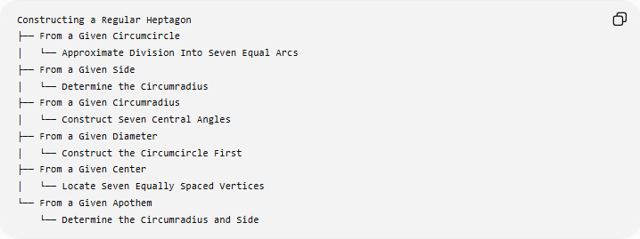
Constructing a Regular Heptagon
├── From a Given Circumcircle
│ └── Approximate Division Into Seven Equal Arcs
├── From a Given Side
│ └── Determine the Circumradius
├── From a Given Circumradius
│ └── Construct Seven Central Angles
├── From a Given Diameter
│ └── Construct the Circumcircle First
├── From a Given Center
│ └── Locate Seven Equally Spaced Vertices
└── From a Given Apothem
└── Determine the Circumradius and Side
These are construction situations based on the given information, rather than different mathematical types of regular heptagons.

Basic Constructions Used
# Source: AI Source: Provided by: [Data Path: Persons Table -> ID Column: 1, Name_En Column: Motasem Essam] -> From: [ChatGPT] on [7/25/2026]
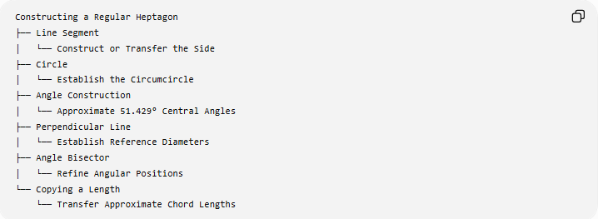
Constructing a Regular Heptagon
├── Line Segment
│ └── Construct or Transfer the Side
├── Circle
│ └── Establish the Circumcircle
├── Angle Construction
│ └── Approximate 51.429° Central Angles
├── Perpendicular Line
│ └── Establish Reference Diameters
├── Angle Bisector
│ └── Refine Angular Positions
└── Copying a Length
└── Transfer Approximate Chord Lengths

Regular Heptagon and Its Circumcircle
# Source: AI Source: Provided by: [Data Path: Persons Table -> ID Column: 1, Name_En Column: Motasem Essam] -> From: [ChatGPT] on [7/25/2026]
For a regular heptagon $ABCDEFG$inscribed in a circle with center $O$:
$$OA=OB=OC=OD=OE=OF=OG=R$$
and the central angles are equal:
$$∠AOB=∠BOC=∠COD=∠DOE=∠EOF=∠FOG=∠GOA=\frac{{360}^{∘}}{7}$$
Therefore:
$$\boxed{\text{Regular Heptagon}=\text{Seven Equal Chords of a Circle}}$$
for the exact geometric definition, although the seven equal divisions cannot be produced exactly by classical straightedge-and-compass construction alone.

Regular Heptagon vs Regular Hexagon
# Source: AI Source: Provided by: [Data Path: Persons Table -> ID Column: 1, Name_En Column: Motasem Essam] -> From: [ChatGPT] on [7/25/2026]
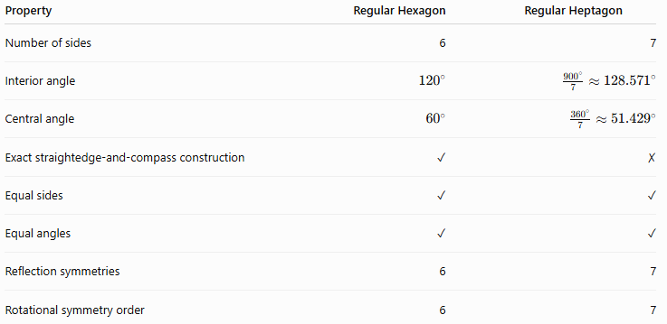
Property | Regular Hexagon | Regular Heptagon
Number of sides | 6 | 7
Interior angle | $${120}^{∘}$$ | $$\frac{{900}^{∘}}{7}≈{128.571}^{∘}$$
Central angle | $${60}^{∘}$$ | $$\frac{{360}^{∘}}{7}≈{51.429}^{∘}$$
Exact straightedge-and-compass construction | ✓ | ✗
Equal sides | ✓ | ✓
Equal angles | ✓ | ✓
Reflection symmetries | 6 | 7
Rotational symmetry order | 6 | 7
The important construction difference is that a regular hexagon has the simple relationship:
$$s=R$$
while the regular heptagon does not have an exact classical straightedge-and-compass construction.

Regular Heptagon vs Other Regular Polygons
# Source: AI Source: Provided by: [Data Path: Persons Table -> ID Column: 1, Name_En Column: Motasem Essam] -> From: [ChatGPT] on [7/25/2026]
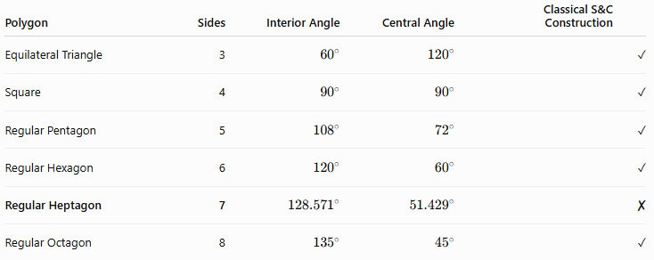
Polygon | Sides | Interior Angle | Central Angle | Classical S&C Construction
Equilateral Triangle | 3 | $${60}^{∘}$$ | $${120}^{∘}$$ | ✓
Square | 4 | $${90}^{∘}$$ | $${90}^{∘}$$ | ✓
Regular Pentagon | 5 | $${108}^{∘}$$ | $${72}^{∘}$$ | ✓
Regular Hexagon | 6 | $${120}^{∘}$$ | $${60}^{∘}$$ | ✓
Regular Heptagon | 7 | $${128.571}^{∘}$$ | $${51.429}^{∘}$$ | ✗
Regular Octagon | 8 | $${135}^{∘}$$ | $${45}^{∘}$$ | ✓

Classification
# Source: AI Source: Provided by: [Data Path: Persons Table -> ID Column: 1, Name_En Column: Motasem Essam] -> From: [ChatGPT] on [7/25/2026]
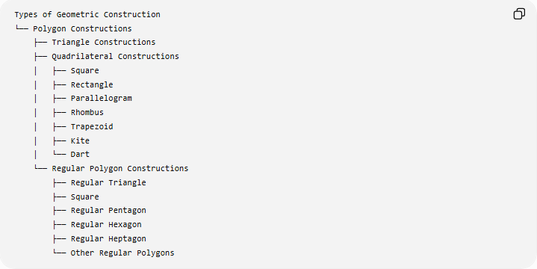
Types of Geometric Construction
└── Polygon Constructions
├── Triangle Constructions
├── Quadrilateral Constructions
│ ├── Square
│ ├── Rectangle
│ ├── Parallelogram
│ ├── Rhombus
│ ├── Trapezoid
│ ├── Kite
│ └── Dart
└── Regular Polygon Constructions
├── Regular Triangle
├── Square
├── Regular Pentagon
├── Regular Hexagon
├── Regular Heptagon
└── Other Regular Polygons
Detailed Classification
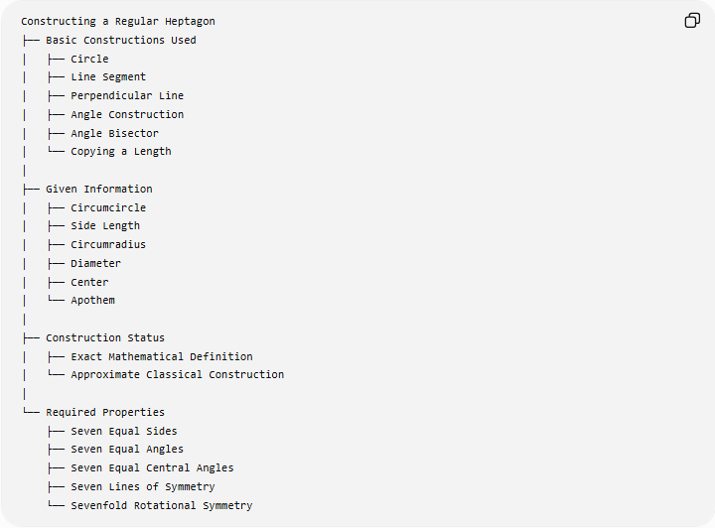
Constructing a Regular Heptagon
├── Basic Constructions Used
│ ├── Circle
│ ├── Line Segment
│ ├── Perpendicular Line
│ ├── Angle Construction
│ ├── Angle Bisector
│ └── Copying a Length
│
├── Given Information
│ ├── Circumcircle
│ ├── Side Length
│ ├── Circumradius
│ ├── Diameter
│ ├── Center
│ └── Apothem
│
├── Construction Status
│ ├── Exact Mathematical Definition
│ └── Approximate Classical Construction
│
└── Required Properties
├── Seven Equal Sides
├── Seven Equal Angles
├── Seven Equal Central Angles
├── Seven Lines of Symmetry
└── Sevenfold Rotational Symmetry

Key Points
# Source: AI Source: Provided by: [Data Path: Persons Table -> ID Column: 1, Name_En Column: Motasem Essam] -> From: [ChatGPT] on [7/25/2026]
- A regular heptagon has exactly 7 equal sides.
- It has 7 equal interior angles:
$$\boxed{\frac{{900}^{∘}}{7}≈{128.571}^{∘}}$$
- Its central and exterior angles are:
$$\boxed{\frac{{360}^{∘}}{7}≈{51.429}^{∘}}$$
- It has 7 lines of reflection symmetry.
- It has rotational symmetry of order 7.
- Its side length for circumradius $R$is:
$$\boxed{s=2R\sin\left(\frac{π}{7}\right)}$$
- A regular heptagon cannot be constructed exactly using only an unmarked straightedge and compass.
- Practical geometric drawings therefore use an approximate construction or an additional tool.
- It has 14 diagonals in total.
- It has three distinct diagonal lengths.
- Unlike a regular hexagon, its side is not equal to its circumradius.

Conclusion
# Source: AI Source: Provided by: [Data Path: Persons Table -> ID Column: 1, Name_En Column: Motasem Essam] -> From: [ChatGPT] on [7/25/2026]
Constructing a Regular Heptagon involves constructing a seven-sided regular polygon with seven equal sides and seven equal angles. Its fundamental angular division is:
$$\boxed{{360}^{∘}÷7≈{51.429}^{∘}}$$
A crucial distinction is that, unlike the regular pentagon and regular hexagon, a regular heptagon is not exactly constructible with an unmarked straightedge and compass alone. Therefore, a classical construction is necessarily approximate unless an additional tool or method is allowed.
For a circumcircle of radius $R$, the side length is:
$$\boxed{s=2R\sin\left(\frac{π}{7}\right)}$$
and the interior angle is:
$$\boxed{\frac{{900}^{∘}}{7}≈{128.571}^{∘}}$$
Thus, the regular heptagon is an important example of the distinction between a mathematically defined regular polygon and a polygon that is exactly constructible by classical straightedge-and-compass methods.

